Project HW5-Checkpoints 3 & 4 (2 p)

Fall 2025

Instructions

Team Number and Project Title: Team 4 and Indoor Farming Pods for Urban Homes

Names of students who actively worked on this assignment (think of it as a mini peer review):
- Ashwini Mahadevaswamy
- Danyelle Veillard
- Madison Rogers
- Mohit Athipedu
- Shamsheer Hussain

Implementation Plan (1 p)

- WBS
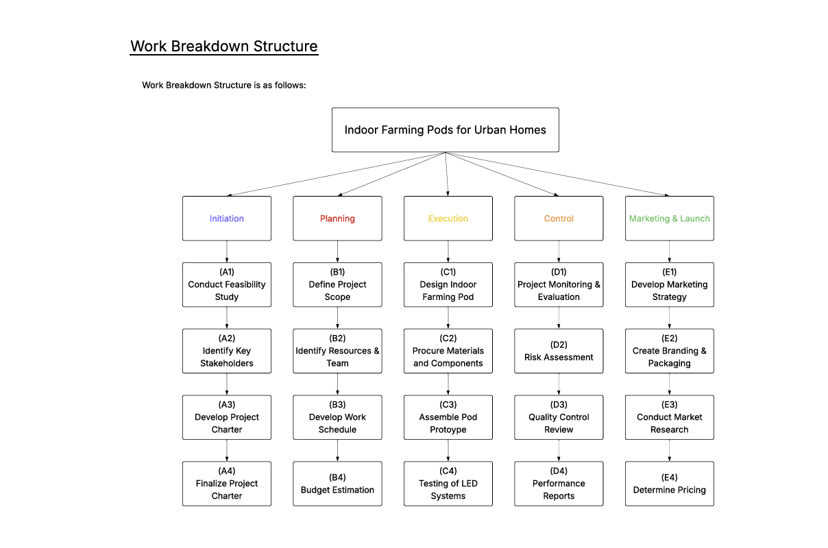

- Responsibility Chart

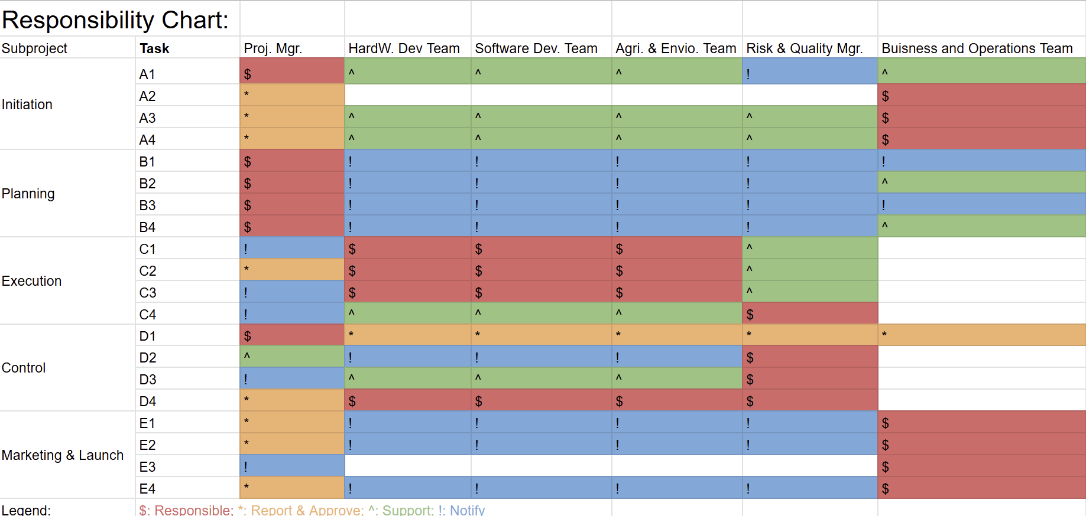

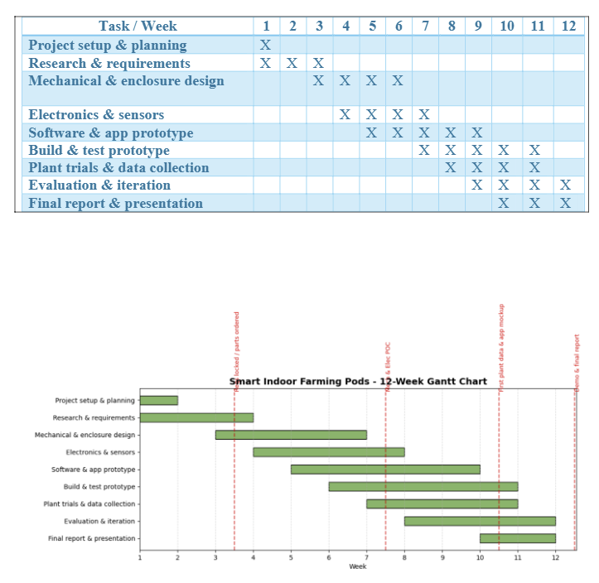
- Gantt Chart (2 versions)
Risk Analysis (1 p)

Top 10 Risks
- Sensor supply delays or faulty sensors - If parts arrive late or maybe if they don’t
work properly, it could delay the prototype or cause wrong readings.
Mitigation: Order from at least two suppliers, keep some backup parts, and design
the setup so sensors can be easily replaced.
- Electronics or microcontroller issues - Wiring errors or incompatible modules
could slow down the development.
Mitigation: Use reliable components like Arduino or ESP32 and test everything on a
breadboard before final assembly.
- Prototype Design Rework / Failures - Parts might not fit, align properly, or work as
intended, which could lead to wasted time in redesigning the prototype and
reordering parts, delaying project timelines.
Mitigation: Create quick 3D print mockups to test fit and alignment, design the
prototype with flexibility for adjustments, and allow time for iterative improvements
during development.
- Plant Growth Performance / Variation - Plants may not grow as expected due to
environmental conditions, nutrient availability, or lighting, giving inconsistent or
unreliable results that affect data collection and analysis.
Mitigation: Use multiple plants of each type, plant in batches to reduce variability,
carefully record environmental conditions for comparison, and repeat trials when
necessary to ensure data reliability.
- App Integration & CAD / Software Compatibility Issues - The mobile or desktop
app may not display sensor data correctly, could crash, or fail to communicate with
hardware. CAD software or file compatibility issues could slow down mechanical or
electronics design and create delays in production.
Mitigation: Build and test a simple version of the app using sample data before
connecting it to the actual sensors, ensure CAD files are compatible with the
chosen 3D printers and fabrication tools, and validate workflows early in the
development cycle.
- IoT / Connectivity Issues - Sensors or pods may fail to transmit data to the app due
to Wi-Fi or IoT connectivity issues, causing gaps in monitoring, delayed feedback, or
incorrect automation.
Mitigation: Test network reliability under different conditions, implement fallback
local data storage, monitor connections continuously, and optimize firmware to
handle intermittent connectivity.
- User Testing / UX Problems - The app interface or pod setup may be confusing,
leading to errors or frustration among users, which could reduce adoption,
satisfaction, or effectiveness of the prototype.
Mitigation: Conduct early and frequent testing with classmates, friends, or target
users, gather detailed feedback, and iteratively improve both the physical pod and
the app interface based on real-world testing.
- Budget Overrun - Expenses could exceed the planned budget due to unforeseen
costs for sensors, electronics, fabrication, or plant materials, which may
compromise the project scope or quality.
Mitigation: Track all spending carefully, prioritize essential components, establish
contingency funds for unexpected costs, and make cost-effective decisions while
maintaining project goals.
- Data loss or sensor logging issues - If the system crashes or data isn’t saved
properly, it could affect analysis.
Mitigation: Enable local backups on the device and export data regularly (like CSV
files).
- Team member unavailability - Illness or scheduling conflicts might cause delays.
Mitigation: Keep shared documentation, cross-train teammates, and leave buffer
time in the project schedule.

- Qualitative Risk Analysis (include a Risk Matrix)

The objective of conducting qualitative risk analysis in our project is to ensure that all project members are prepared and aware of the potential risks that could impact our design, testing, and delivery schedule. This analysis allows the team to evaluate each identified risk based on its likelihood and impact, helping prioritize which ones need the most attention or mitigation planning.
We are using a 5x5 risk matrix to evaluate and visualize the qualitative risk levels for our top ten project risks. This matrix helps the team understand and contextualize the likelihood and consequences of each risk throughout the 12-week project timeline. Each risk was assessed collaboratively based on project scope, available resources, and technical complexity.

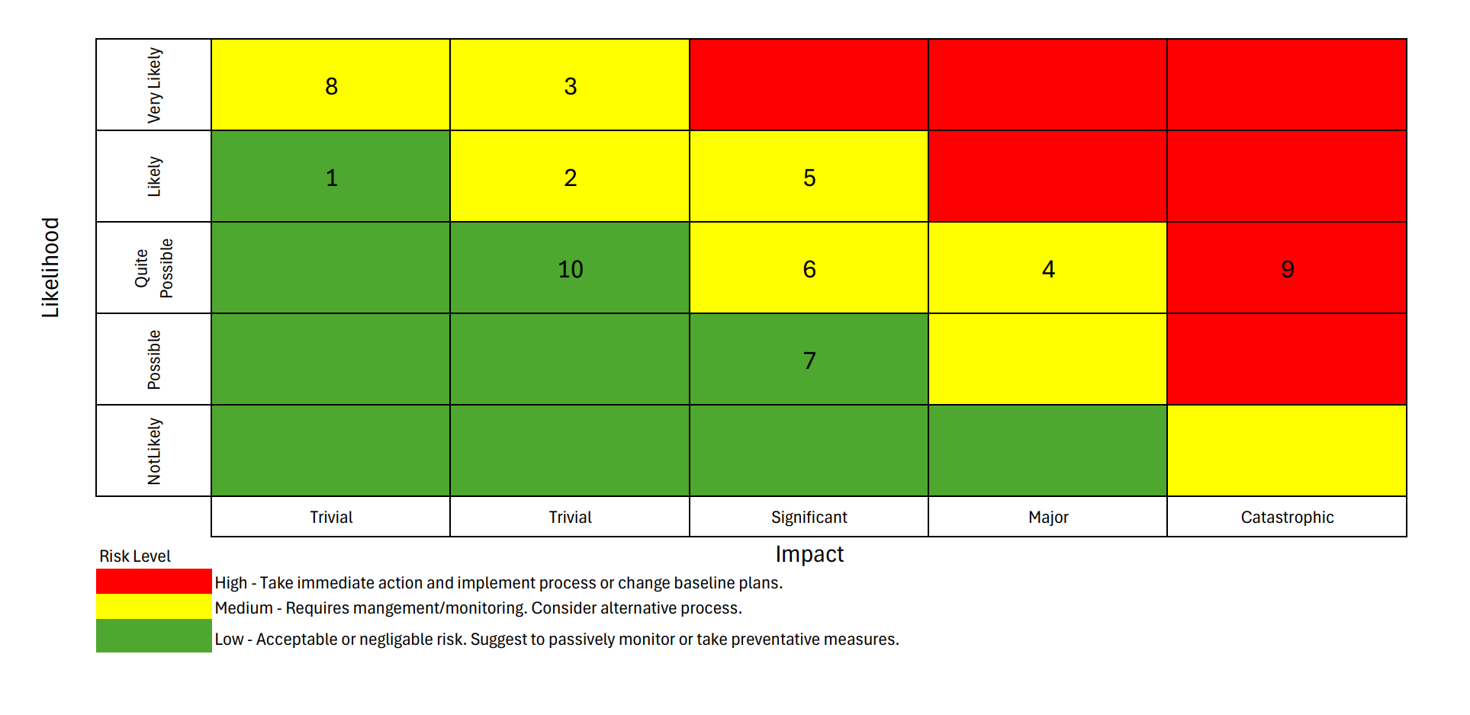

- Quantitative Risk Analysis (calculate the FMEA RPN)
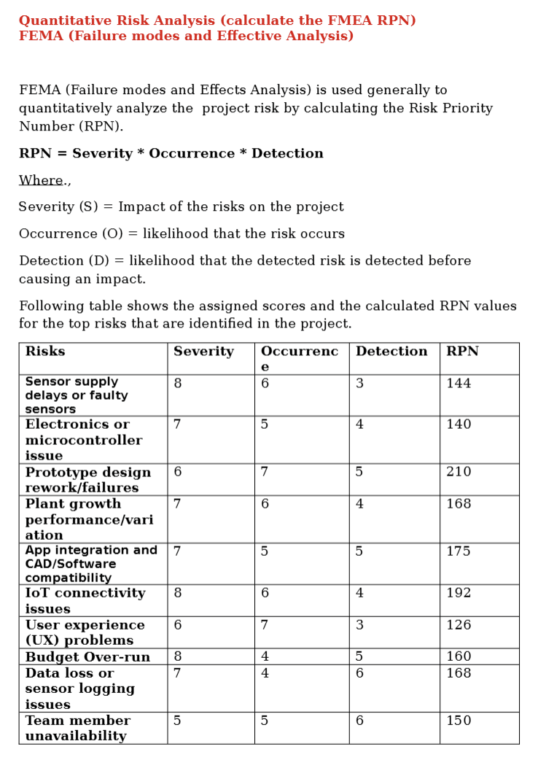

The higher RPNs for the risks like prototype redesign/rework (210),
Connectivity Issues (192), app integration failure (175) are the critical
areas to focus on the mitigation efforts on. This combined analysis
provides a comprehensive risk preparedness and informed allocation of
resources to reduce the overall project risks.

